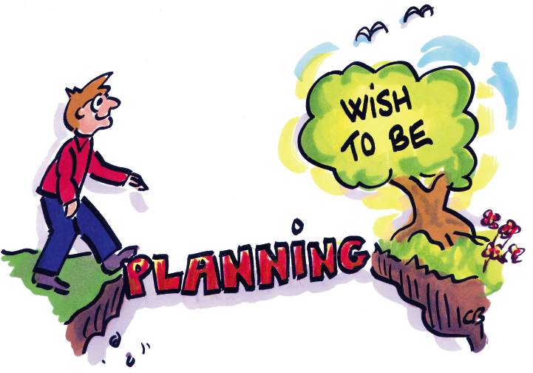
Your Personal Action Plan

Look back at the tools and ideas that were at play during the course. Evaluate which tools and ideas could contribute to strengthening your personal planning and efficiency.

Which specific activities do I intend to initiate? | When should the activity begin? | What are some possible obstacles that could prevent it from succeeding?  How do I intend to tackle these obstacles? | Who should be notified, be consulted, help, be involved, be sworn in … | When and how do I intend to follow up?

